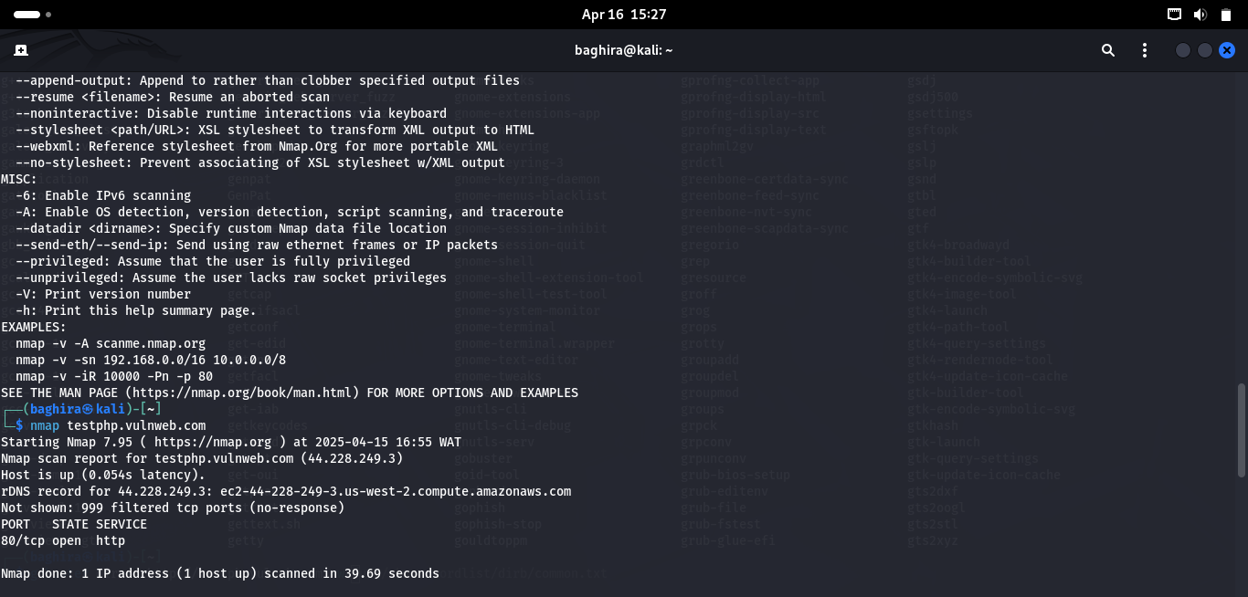

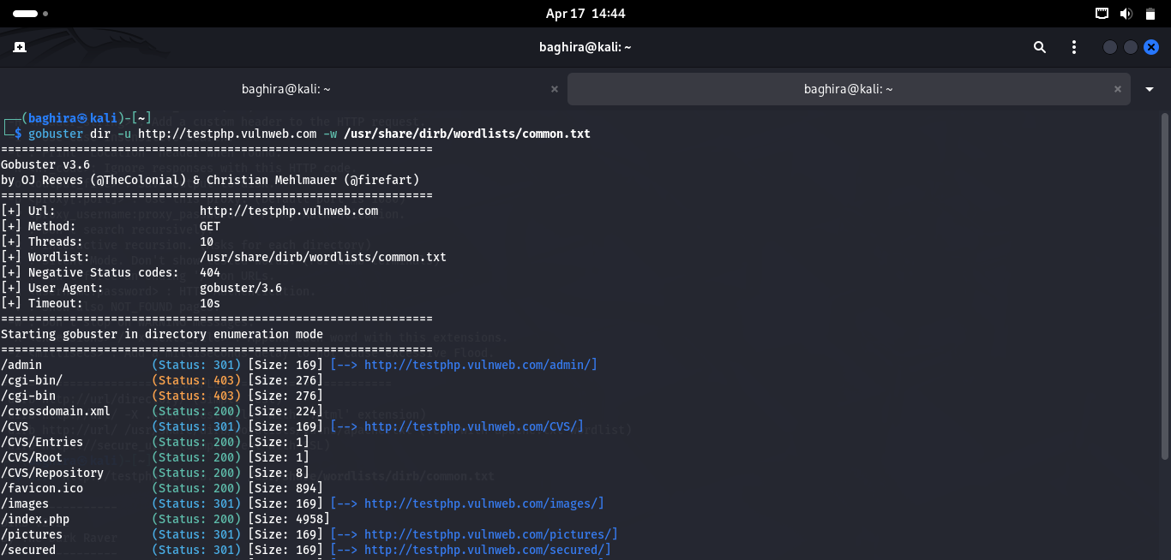

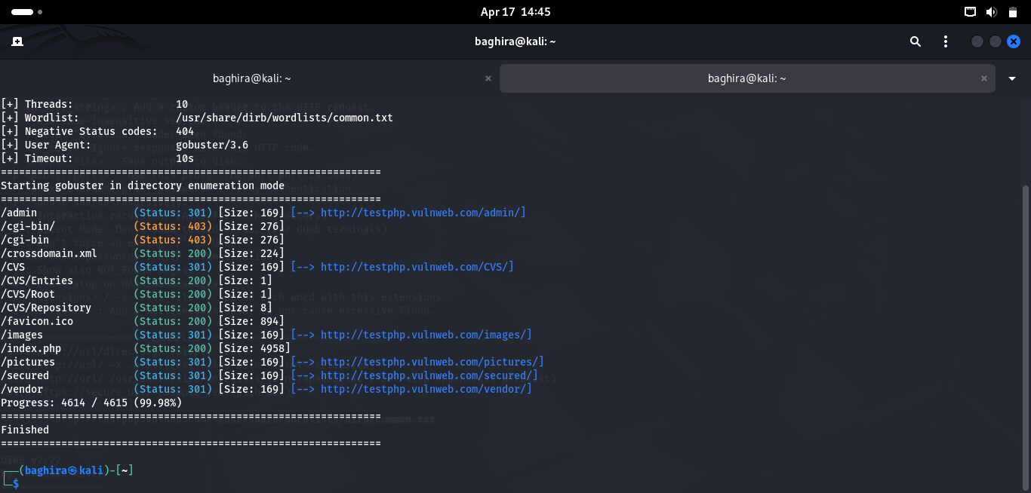

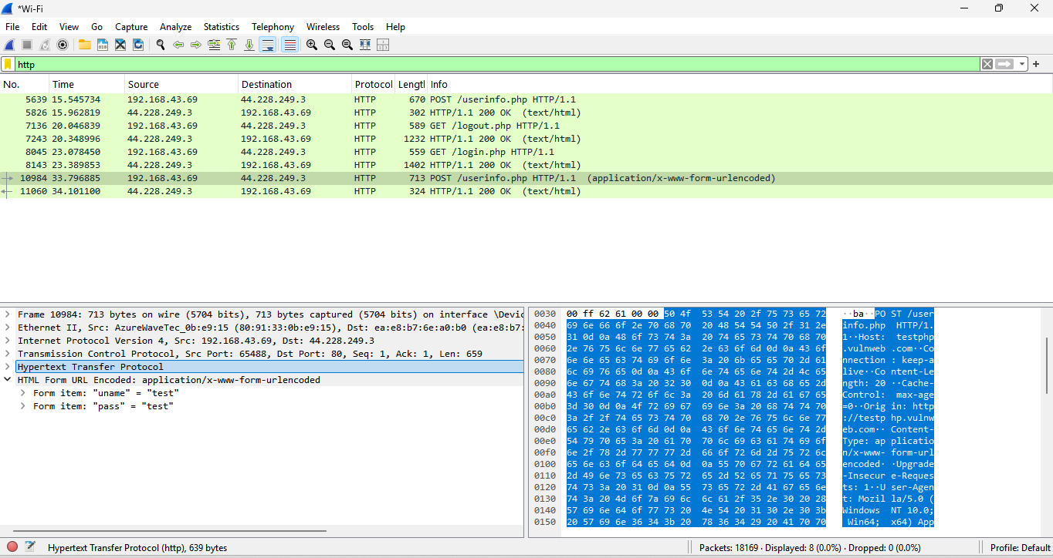

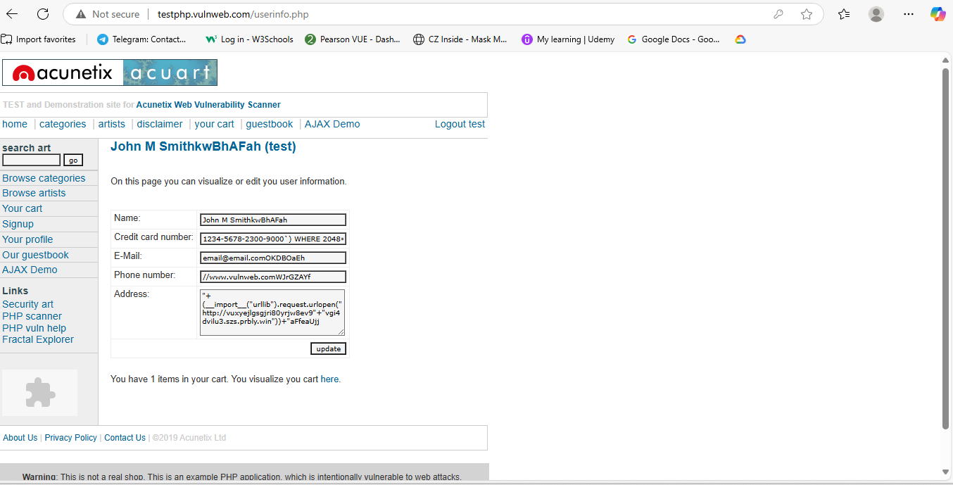  
  
  
  
  
  
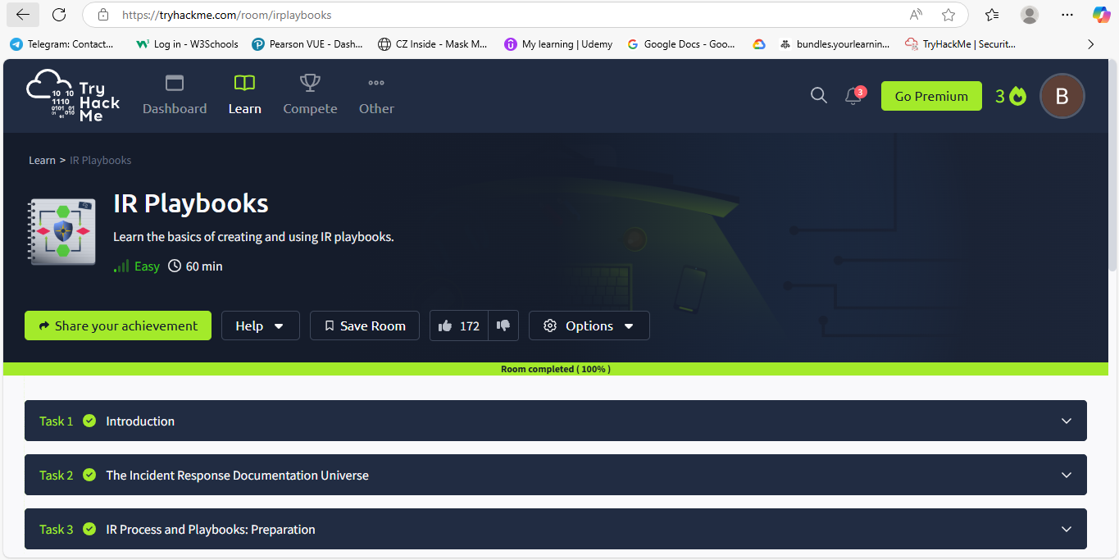  
  
  
  
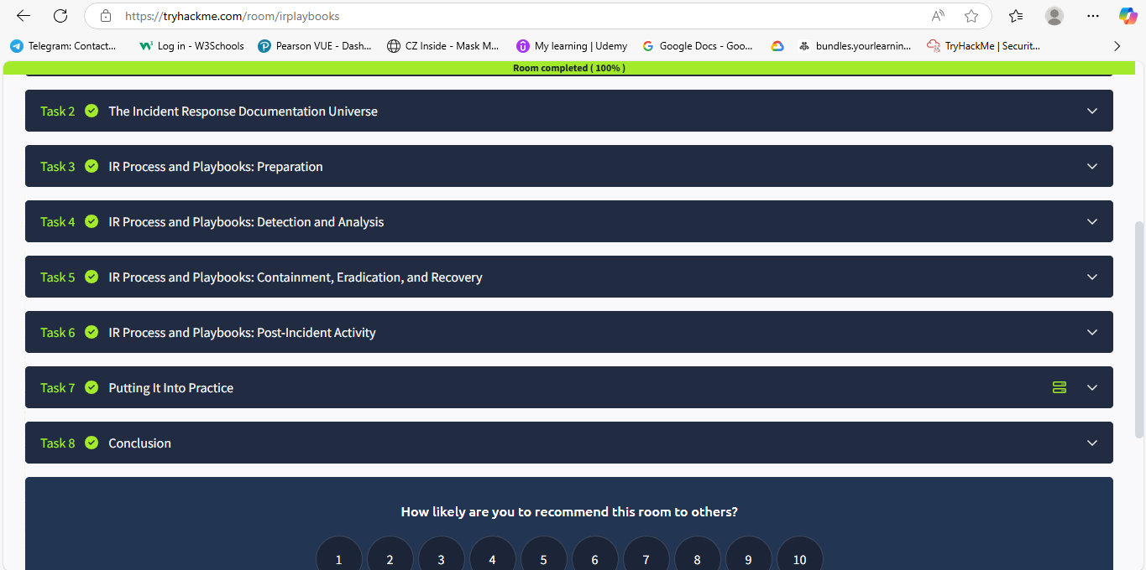  
  
  
  
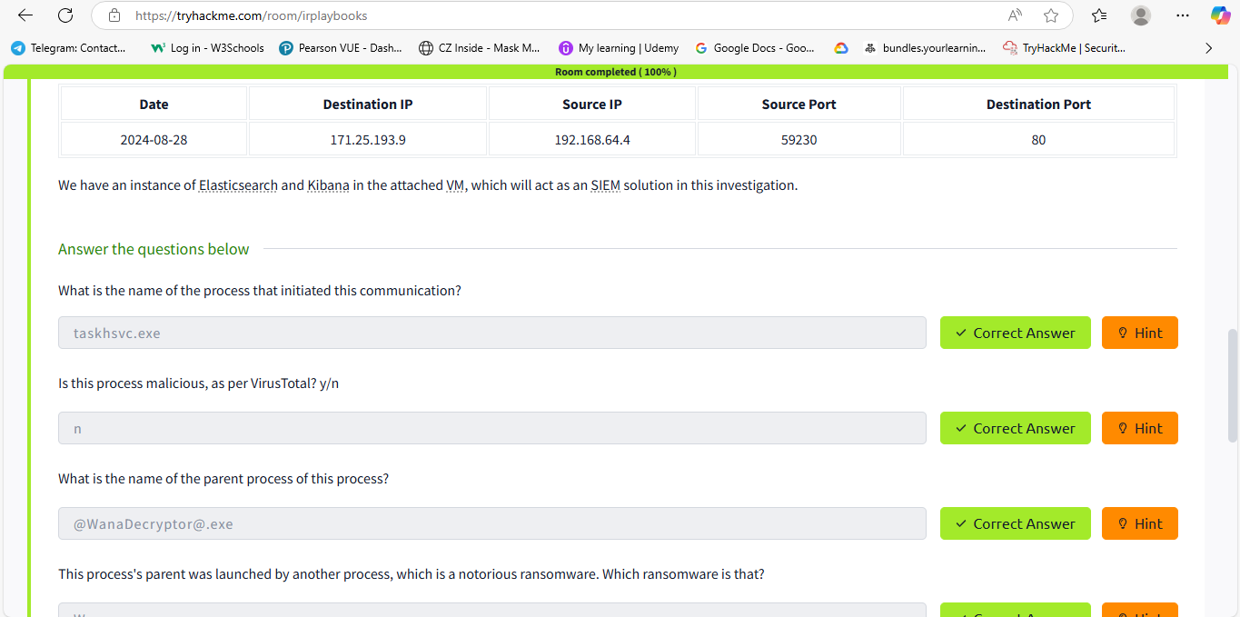  
  
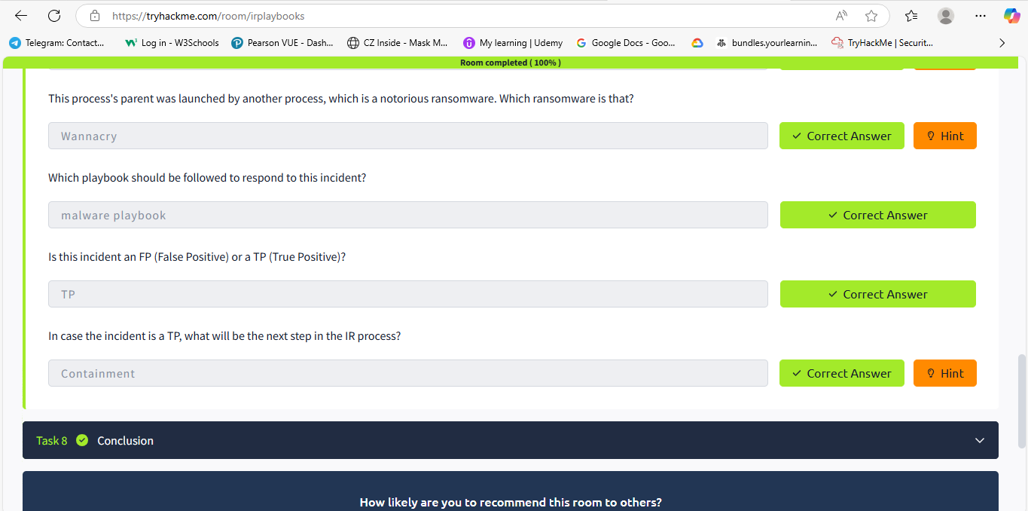  
  
  
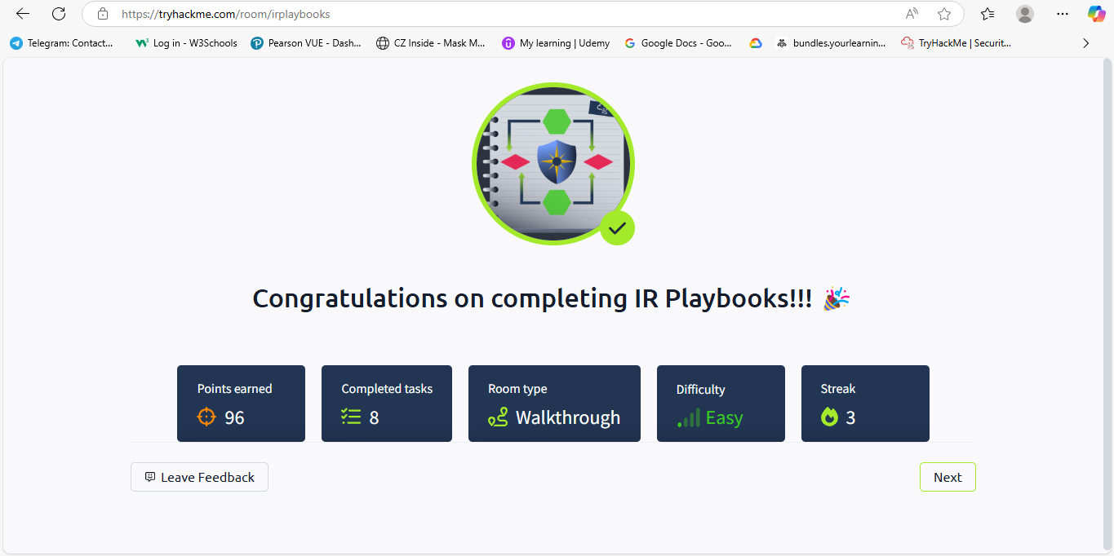  
  
  
  
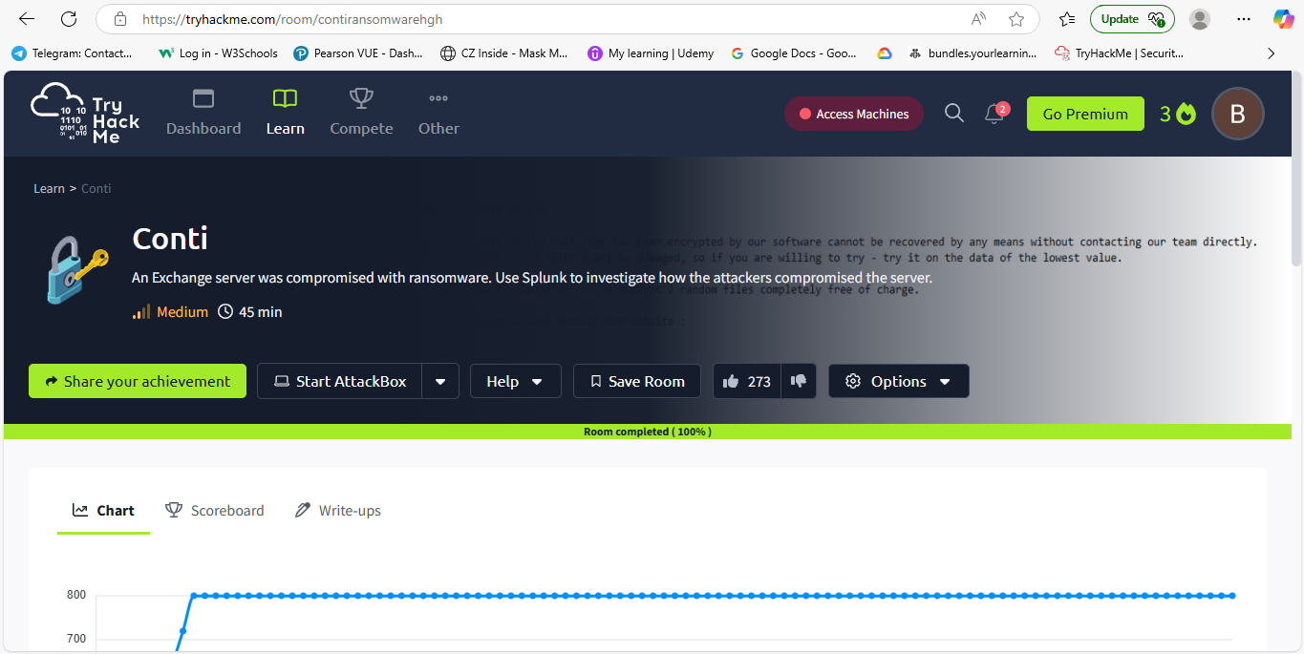  
  
  
  
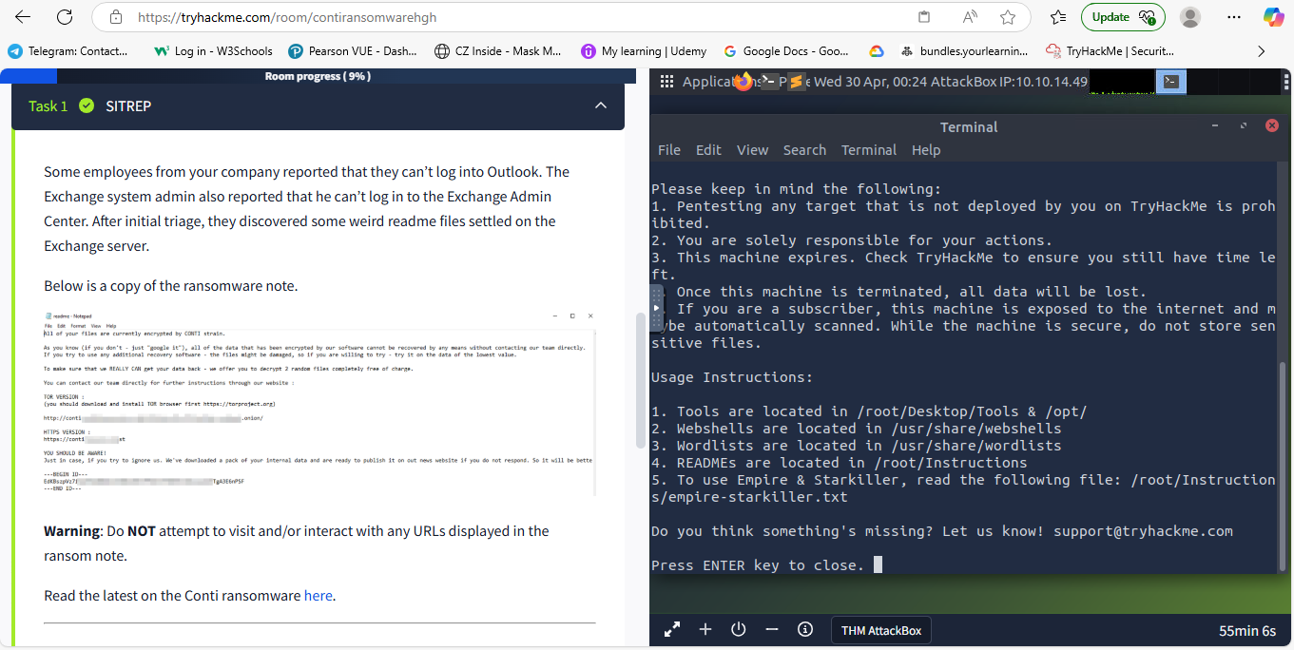  
  
  
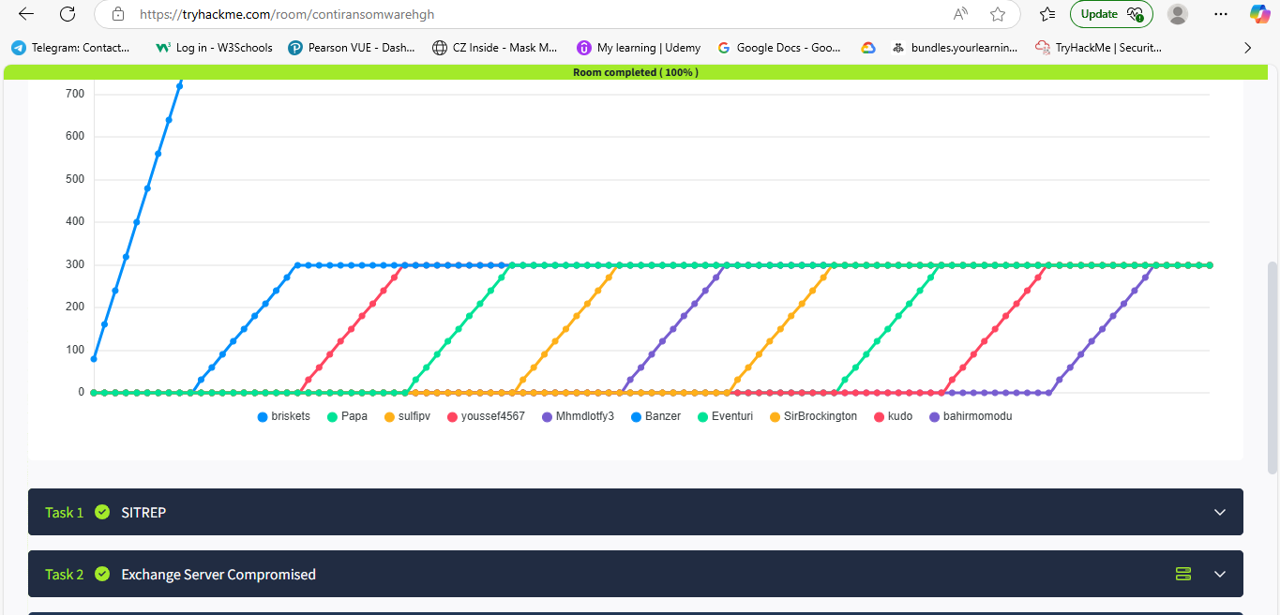  
  
  
  
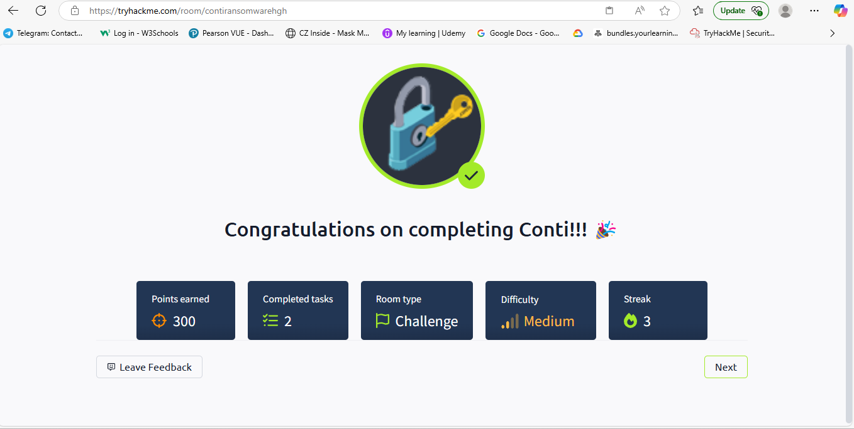

**Internship Final Report**

**Student Name**: Momodu Bahir Qasim

**University**: Amrita Vishwa Vidyapeetham

**Major**: Computer Science

**Internship** **Duration**: April 10th, 2025 – May 3th, 2025

**Company**: Hack Secure

**Domain**: Cyber Security

**Mentor**: Mr Nishant Prajapati

**Assistant** **Mentor**: Mr Aman Pandey

**Cordinator**: Mr Shivan Kapoor

**Objectives**  
 My primary objectives for this internship were to:

1. Develop a deep understanding of cybersecurity principles and practices.
2. Gain hands-on experience in identifying, analyzing, and mitigating security threats.
3. Enhance my skills in using cybersecurity tools and techniques in real-world scenario.

**Tasks and Responsibilities**

During the course of the internship, I was assigned the following tasks:

* **Penetration testing :** I carried out brute-force attacks and found all active directory present on websites using tools Gobuster.
* **Vulnerability Scanning :** performed vulnerability assessment through Nmap on a target website to find all open ports and potential flaws.
* **Traffic Analysis :** Intercept network traffic using wireshark to capture and analyze credentials in transmission.
* **SQL injection:** I carried out my SQL injection trying multiple queries on the search page.
* **Payload creation:** I injected malicious javascript on the search page to determine if the website is vulnerable to stored or reflected XSS attacks.

**Learning outcomes**

* **Technical Proficiency:** I gained practical experience in various cybersecurity tools and techniques, including vulnerability scanning, penetration testing, and traffic analysis.
* **Understanding of cybersecurity lifecycle**: I developed a comprehensive understanding of the steps involved in securing systems, from initial vulnerability assessment to implementing mitigations.
* **Problem-Solving skills:** Tackling complex security challenges enhanced my analytical thinking and my ability to devise effective solutions under pressure.
* **Professional Development:** My experience improved my ability to work in a team, communicate technical information clearly, and manage time efficiently in a fast-paced environment.

**Challenges and Solutions**

* **Adapting to complex tools:** Initially, mastering advanced cybersecurity tools like Nmap, Gobuster and Wireshark was a bit complicated. I overcame this by dedicating time to study tutorials and practicing in a simulated environment, which significantly improved my proficiency.
* **Handling Advanced Security Scenarios:** The complexity of real-world security threats required a deep understanding of underlying principles. I tackled this by engaging in continuous learning and seeking guidance from my coordinator and team members.
* **Imposter** **Syndrome:** I felt inadequate or doubt my abilities, especially when working certain task, but I got motivated by the phrase ‘learning makes perfect’, so that build my confidence.

**Conclusion**

My internship at Hack Secure was an enriching experience that significantly expanded my knowledge and skills in cybersecurity. The practical exposure to real-world security challenges and the application of advanced tools have solidified my interest in pursuing a career in cybersecurity. This experience has been instrumental in preparing me for the complexities of the cybersecurity field.

**Acknowledgement**

I express my sincere gratitude to Hack Secure, especially my mentor, Mr. Nishant Prajapati, and assistant mentor Mr. Aman Pandey, for their guidance and support throughout my internship. I also thank Amrita Vishwa Vidyapeetham for providing this internship opportunity, which has been crucial in my personal and professional development. This report encapsulates the essence of my internship experience, highlighting the integration of academic knowledge with practical skills in a professional setting. It reflects my journey of learning, growth, and development in the field of cybersecurity.